KASAPON

November 19,2002

Dear Purchasing Manager,

Save resources and build up company image . . .

In order to catch up with the needs of modern city, we sincerely introduce you our advanced design equipment --- Auto Umbrella Plastic Bag Stand which can solve your problem in rainy days, save labor force, keep your customers free from wet umbrella, avoid slippery accident, keep clean and maintain comfortable environment for your valuable customers. We believe that better service and image can provide more competitive advantages to your business.

We are the sole agent with patent registered . . .

You may meet some other infringed equipment in the market, however please mind their unreliability and functional problem, if they cannot work smoothly and reliably, the problem created will be more serious than not using such kind of equipment. Our Auto Umbrella Plastic Bag Stand (KASAPON) with good reputation has about 10 years history and it has been patented in Japan, Hong Kong, China and many countries in Europe. We are the sole agent of this equipment in Hong Kong and China market. Please check carefully before you make the purchase decision. We are waiting for the opportunity to serve you.

Comparison of Originator and Pirated Auto Umbrella Stand
 | Originated Auto Umbrella Stand | Pirated Auto Umbrella Stand
1. Function | Guarantee | Not guarantee
2. Material of the umbrella stand | Made of stainless steel,  firm and strong | Made of general iron, steel  and plastic
3. Material of the umbrella plastic bag | Environmental plastic bag | General plastic bag
4. Legal status | Legally, we’ve the patent of both umbrella stand and plastic bag | Illegal
5. Supplier | Related company of a  HK public listed company | Small-sized firm
6. Supply of related products | Stable | Usually unstable or stop operation to avoid infringement problem.
7. Repair & Maintenance | Durable | Need repairing frequently
8. Painting of umbrella stand | Long lasting | Color fade out easily

For any inquiries, please call our Customer Care Hotline at 2304 4818 for demonstration.

Yours faithfully,
Yee King Electronics Co. Ltd.
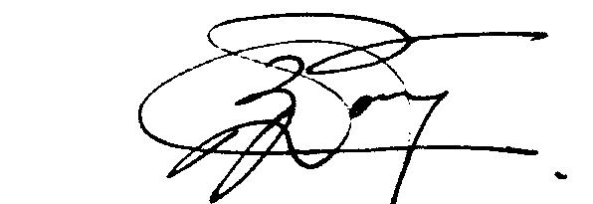
Zinnie Wong
Manager, Customer Care

Our company is established in 1980, we are a related company of a HK public listed company and we are confident to be your reliable partner in rainy days!

 Yee King Electronics Company Limited
Flat C, 10/F., China Trade Centre, 122-124 Wai Yip St., Kwun Tong, Hong Kong.
Tel: 852-2304 0382 Fax: 852-2304 4323
Website: www.yeeking.com E-mail: yk@yeeking.com

